Output Images

**CREDENTIAL PAGE**

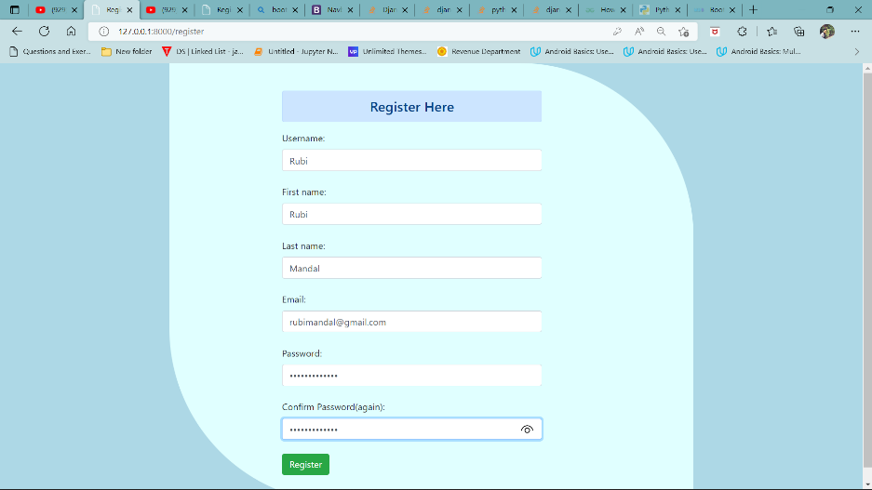

Fig1: Registration Form

User have to register through this form before getting

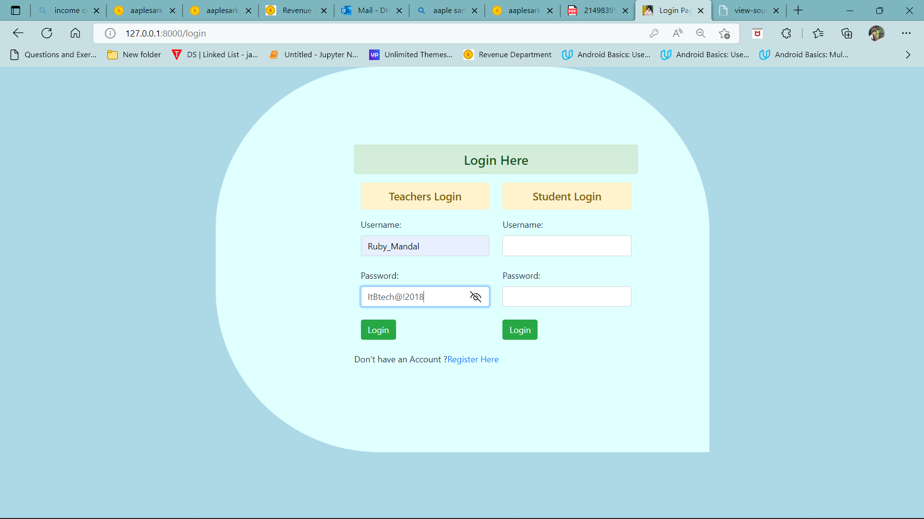

Fig .2. Teacher/Student login

Both teacher and Student can login through this page after registration is done

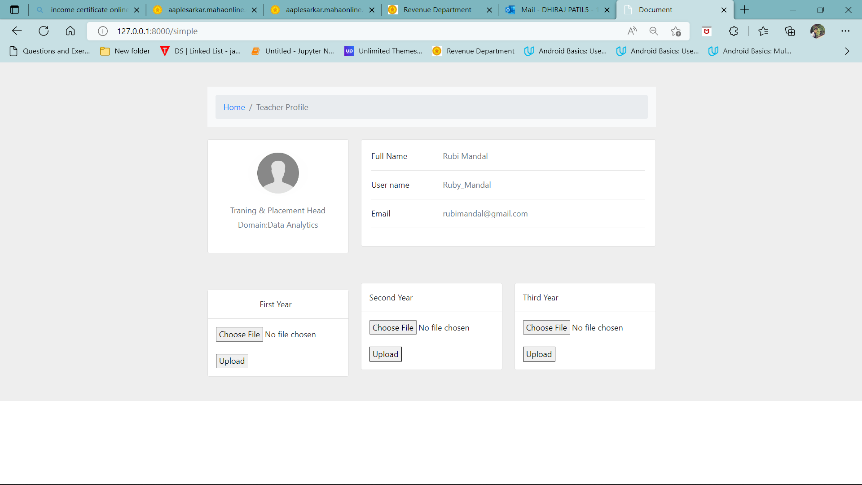

Fig 3.Teacher Profile

Teacher can update their data and upload excel sheet Class data From here

**ADMIN SECTION**

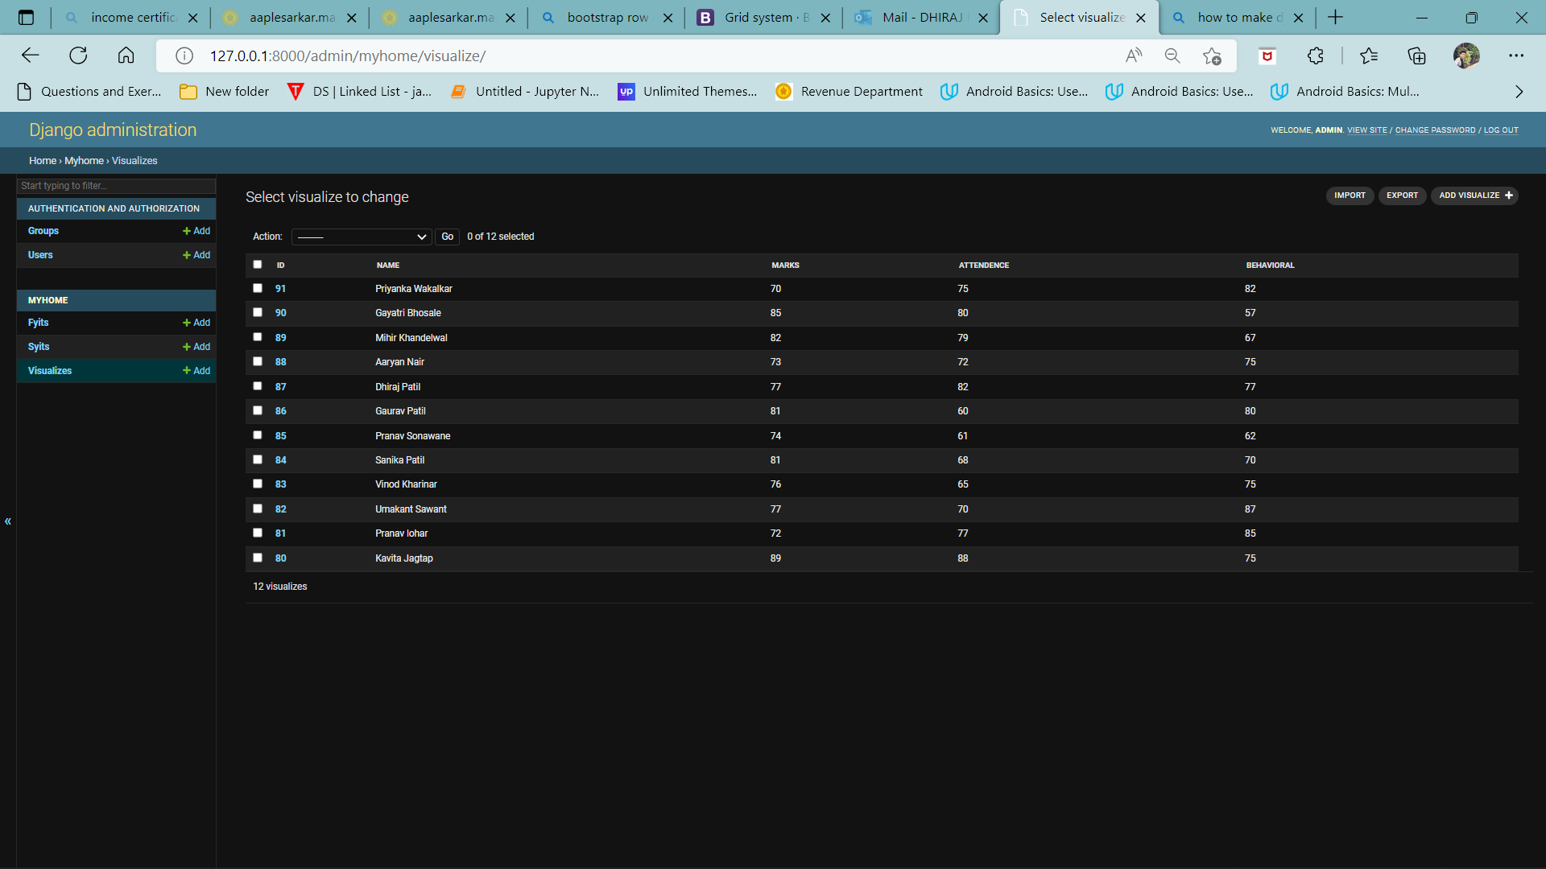

Fig .3. Data of Students of a class

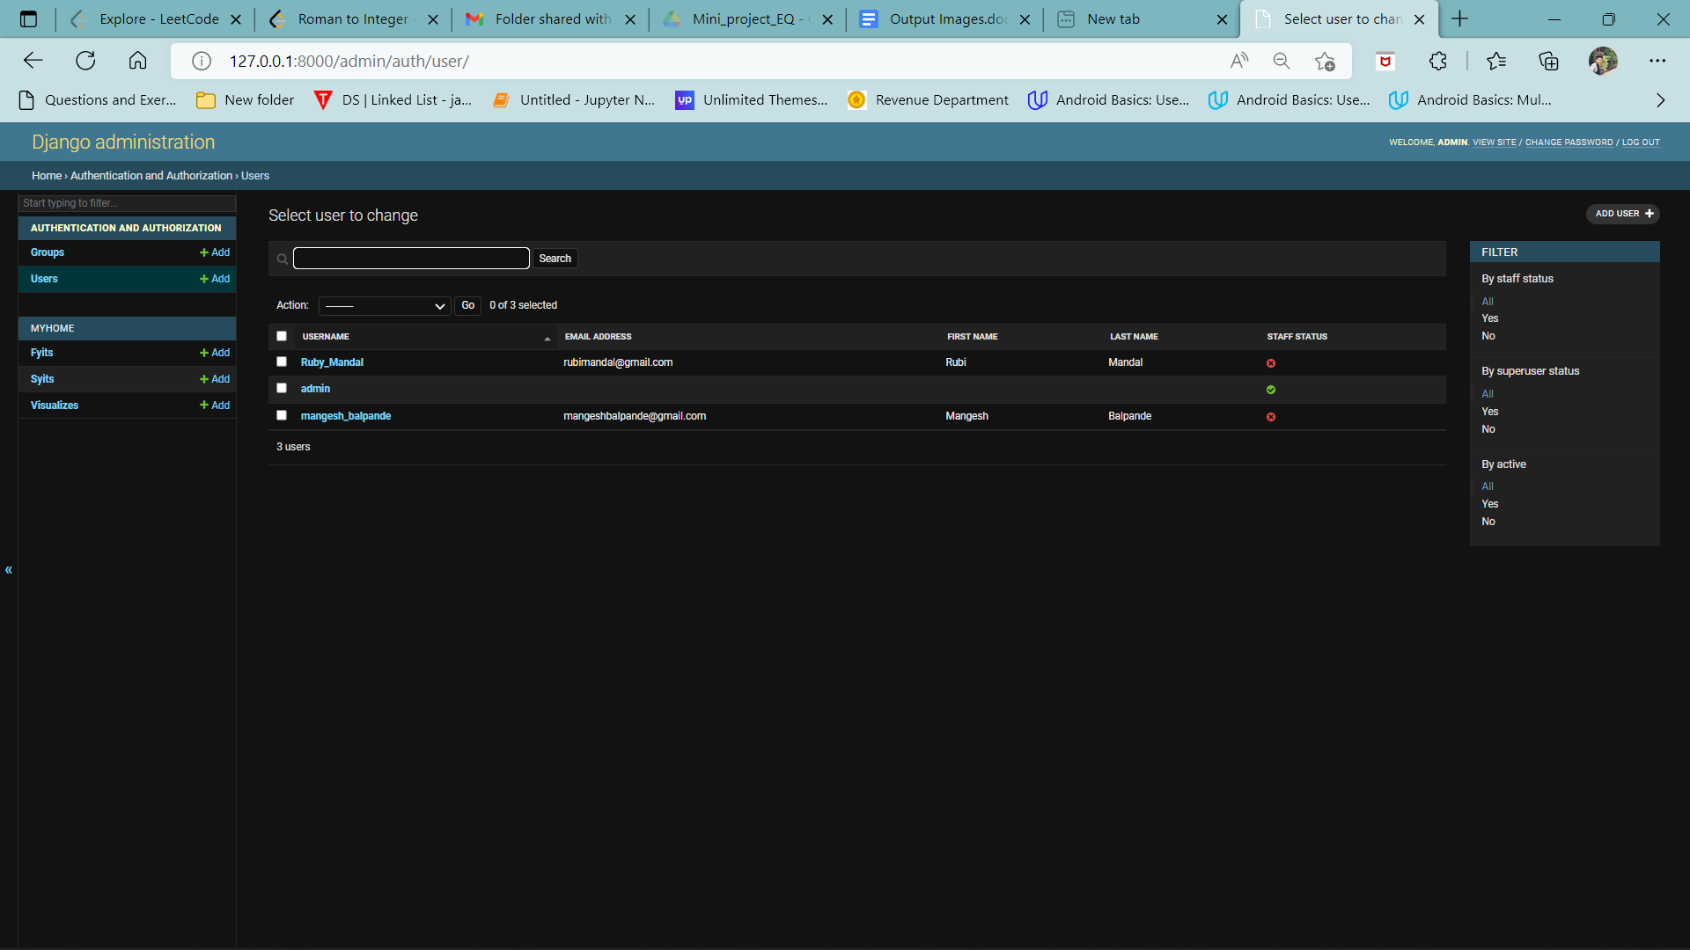

Fig . 4. Registered Users of the website

**CLASS PERFORMANCE SECTION**

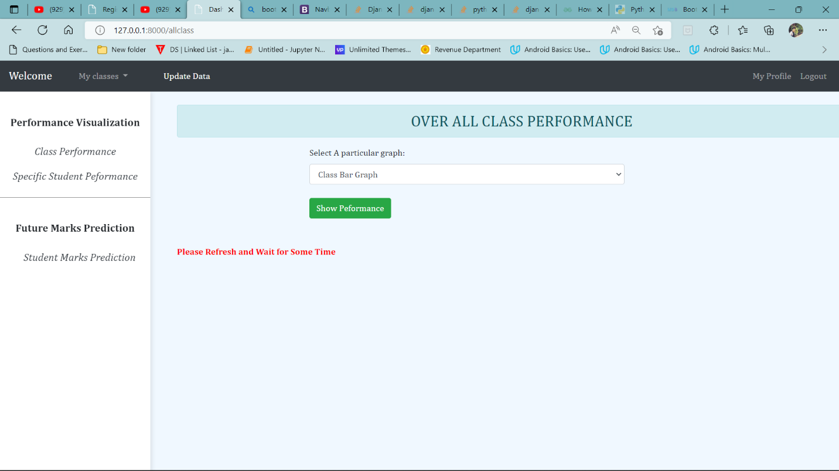

Fig .4. All Class Performance

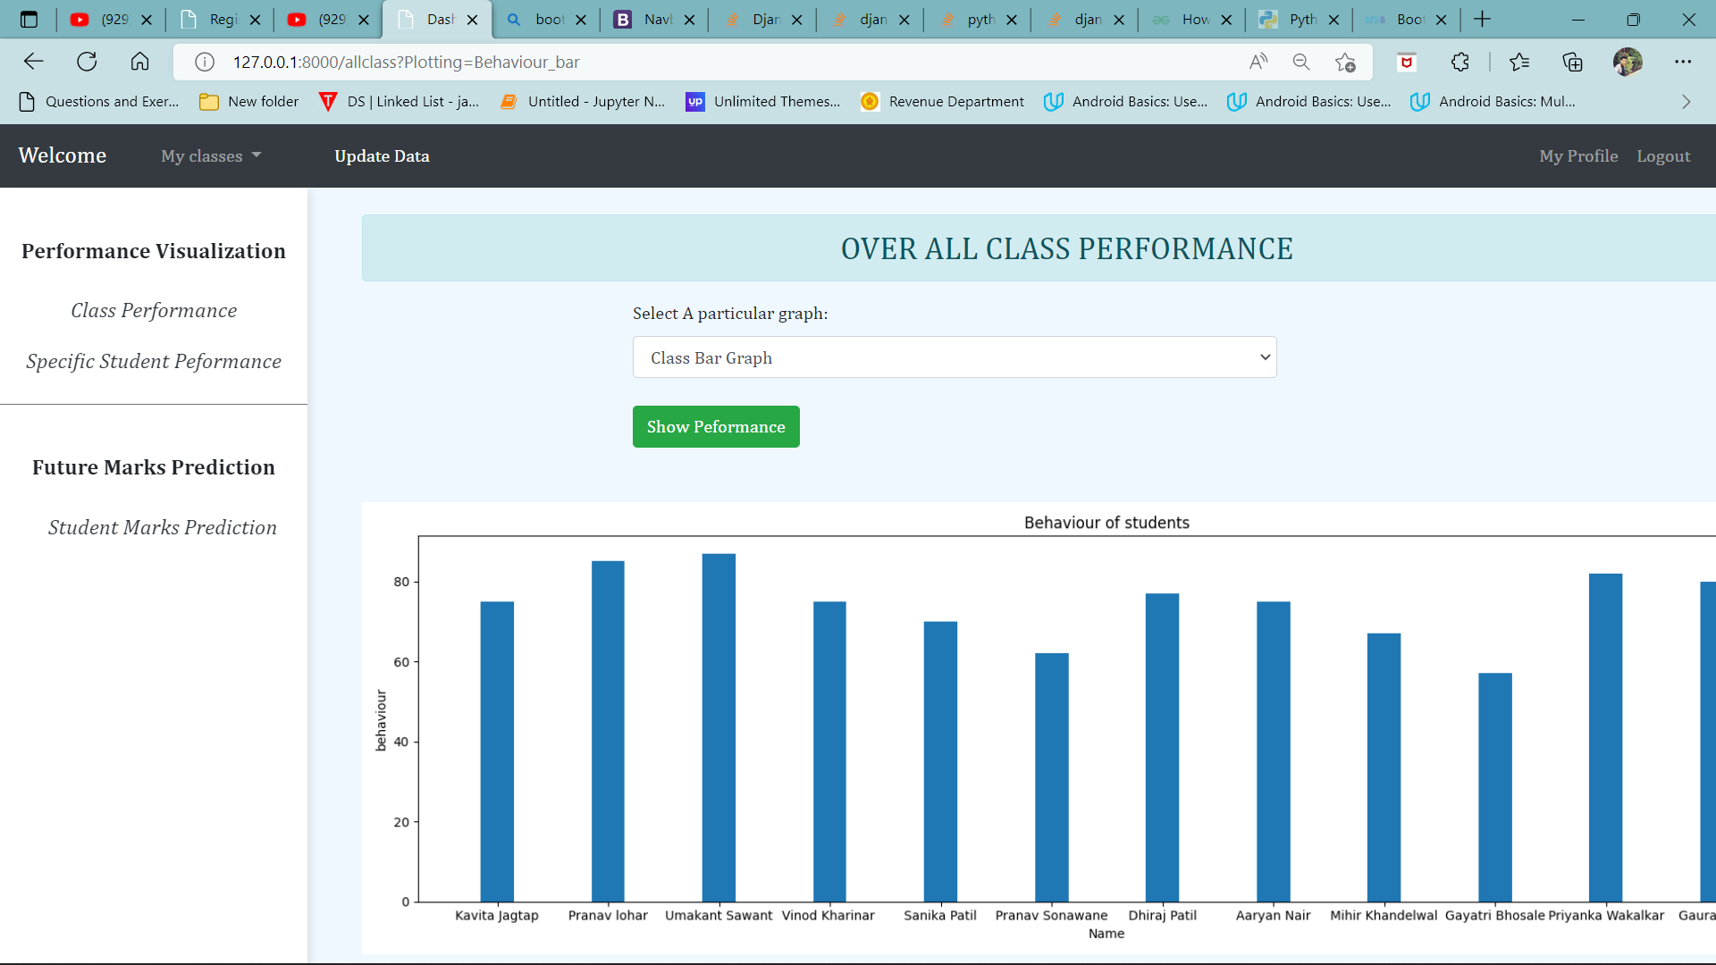

Fig .5. Result of Behavioral Performance

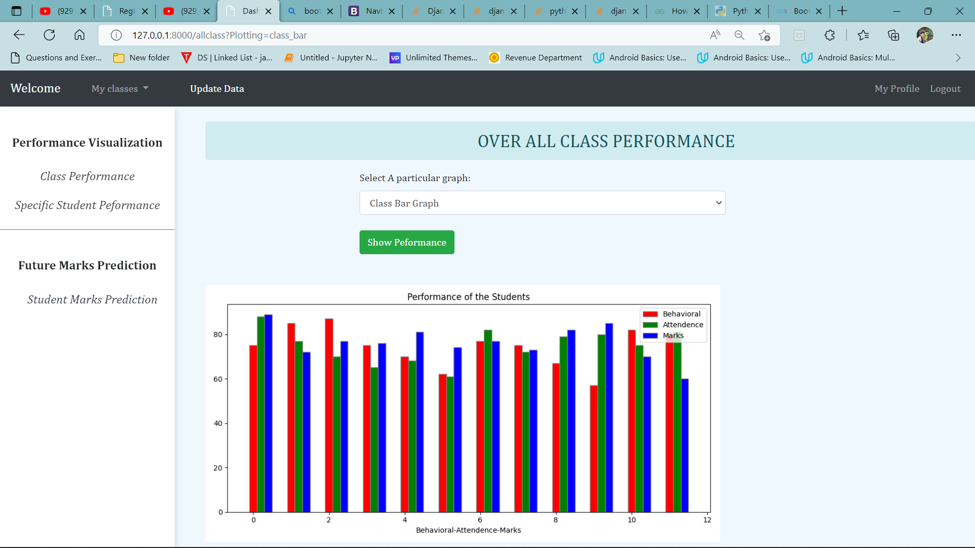

Fig. 6. Performance with all three attributes a.) Behavior b.) Marks c.)Attendance

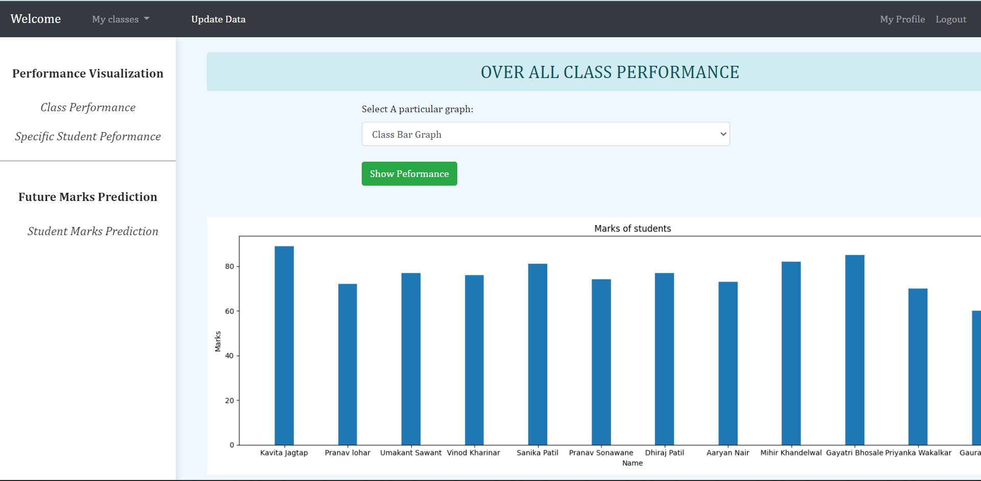

Fig .7. Result of Marks Performance

**STUDENT SPECIFIC PERFORMANCE SECTION**

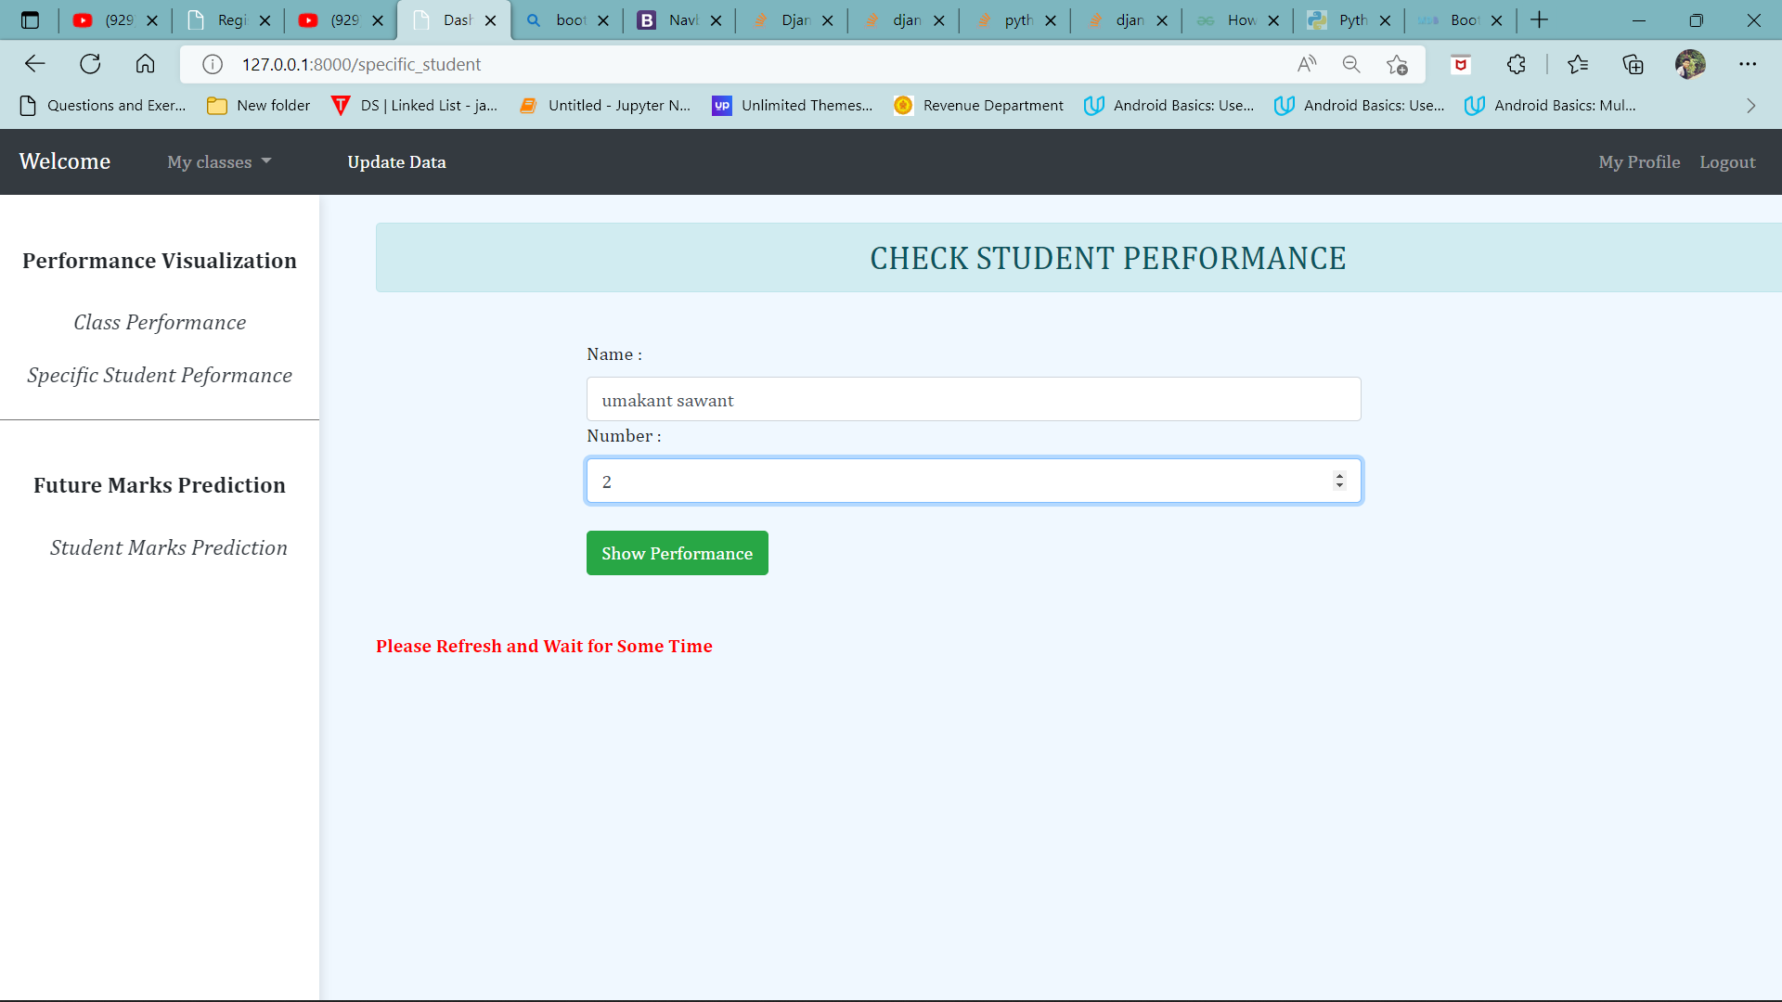

Fig .8. Check Specific Student Performance

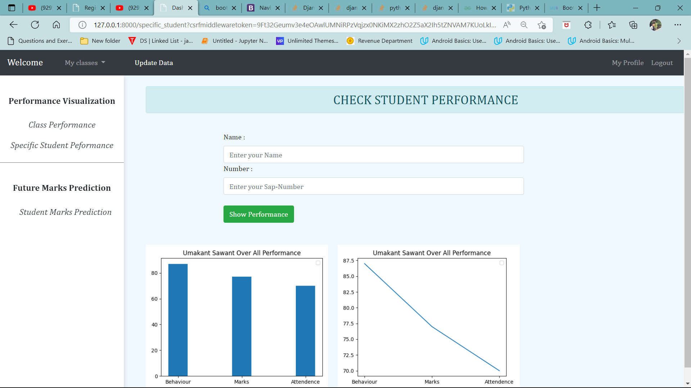

Fig .9. Results

**PREDICTION SECTION**

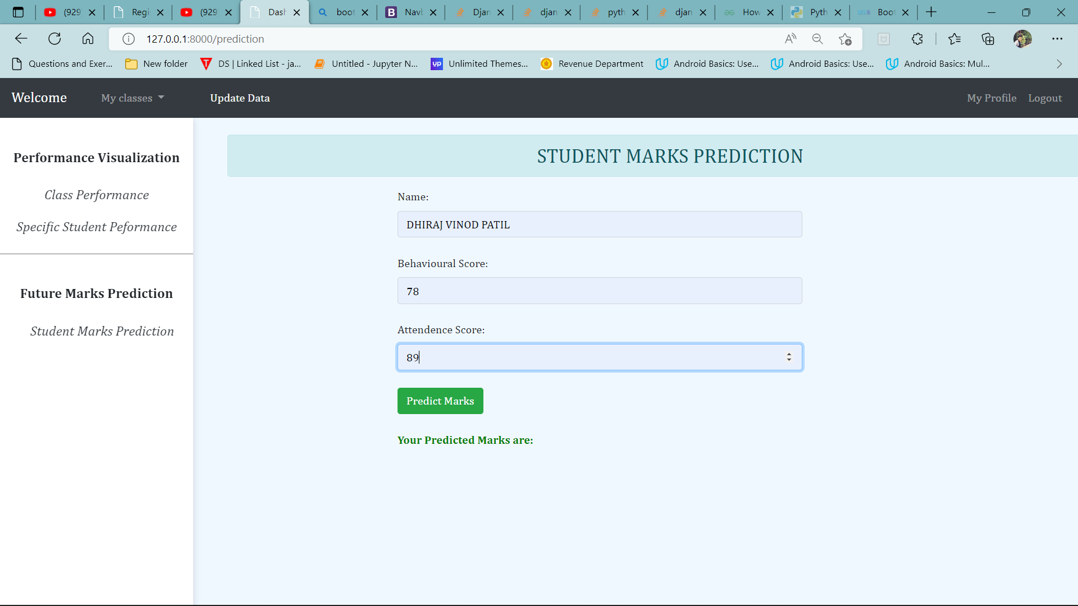

Fig 10. Marks Prediction based on Current Behavior and Attendance

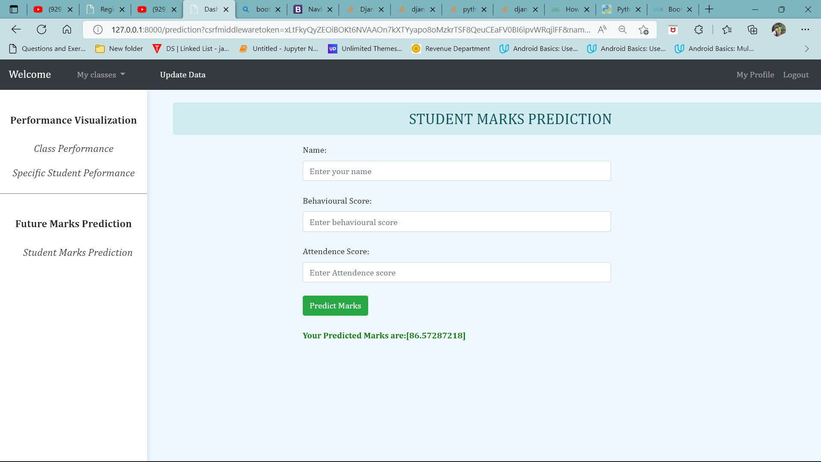

Fig 11. Predicted Result

**DATA COLLECTION SECTION**

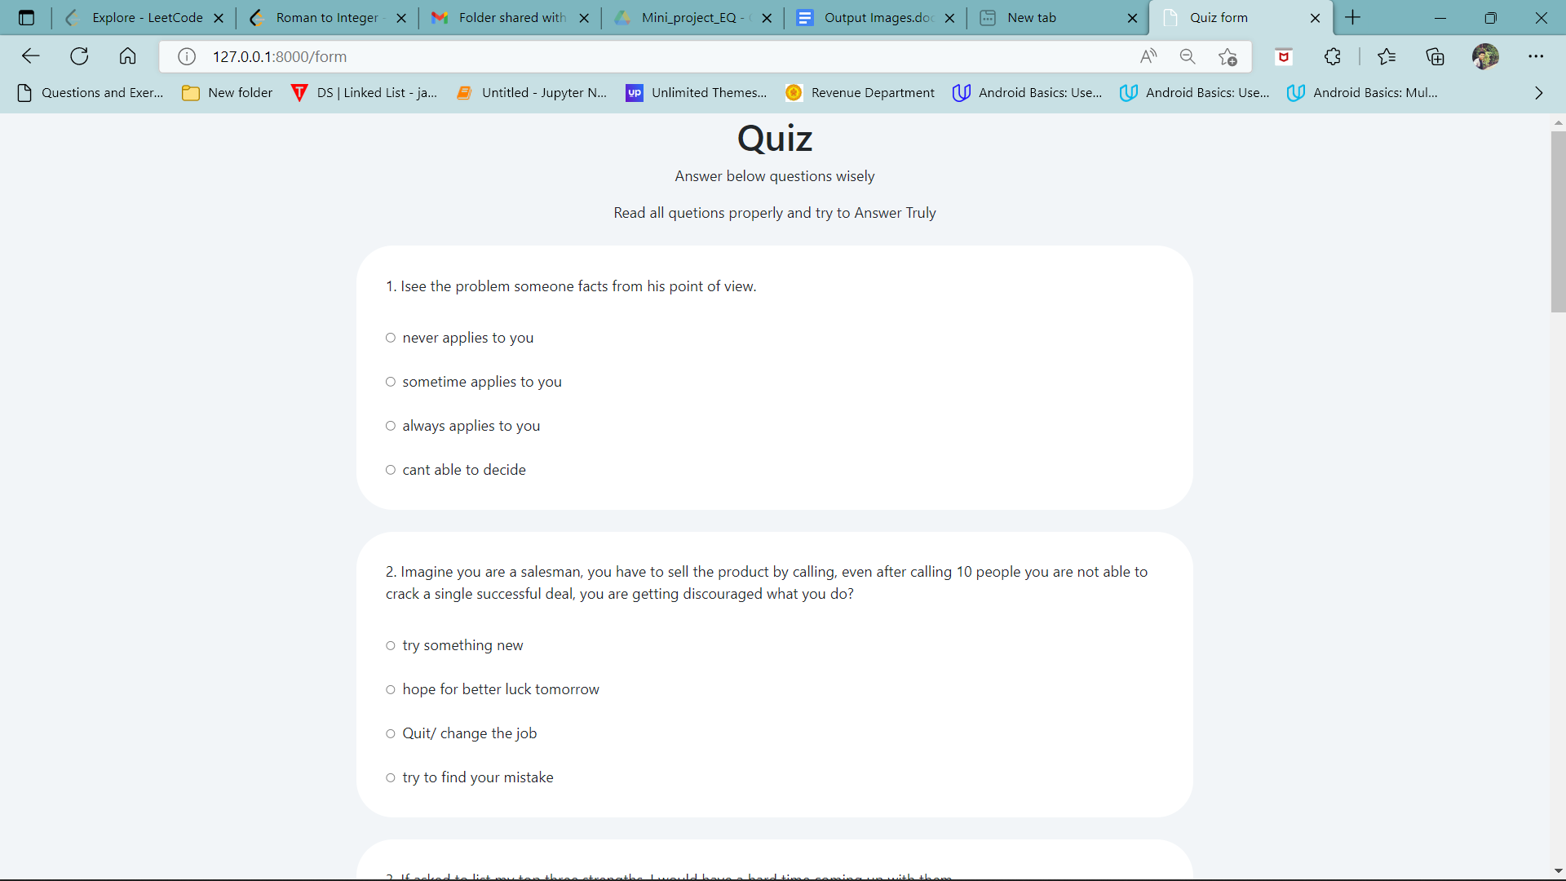

Fig 12. Behavioral Data Collection through Forms

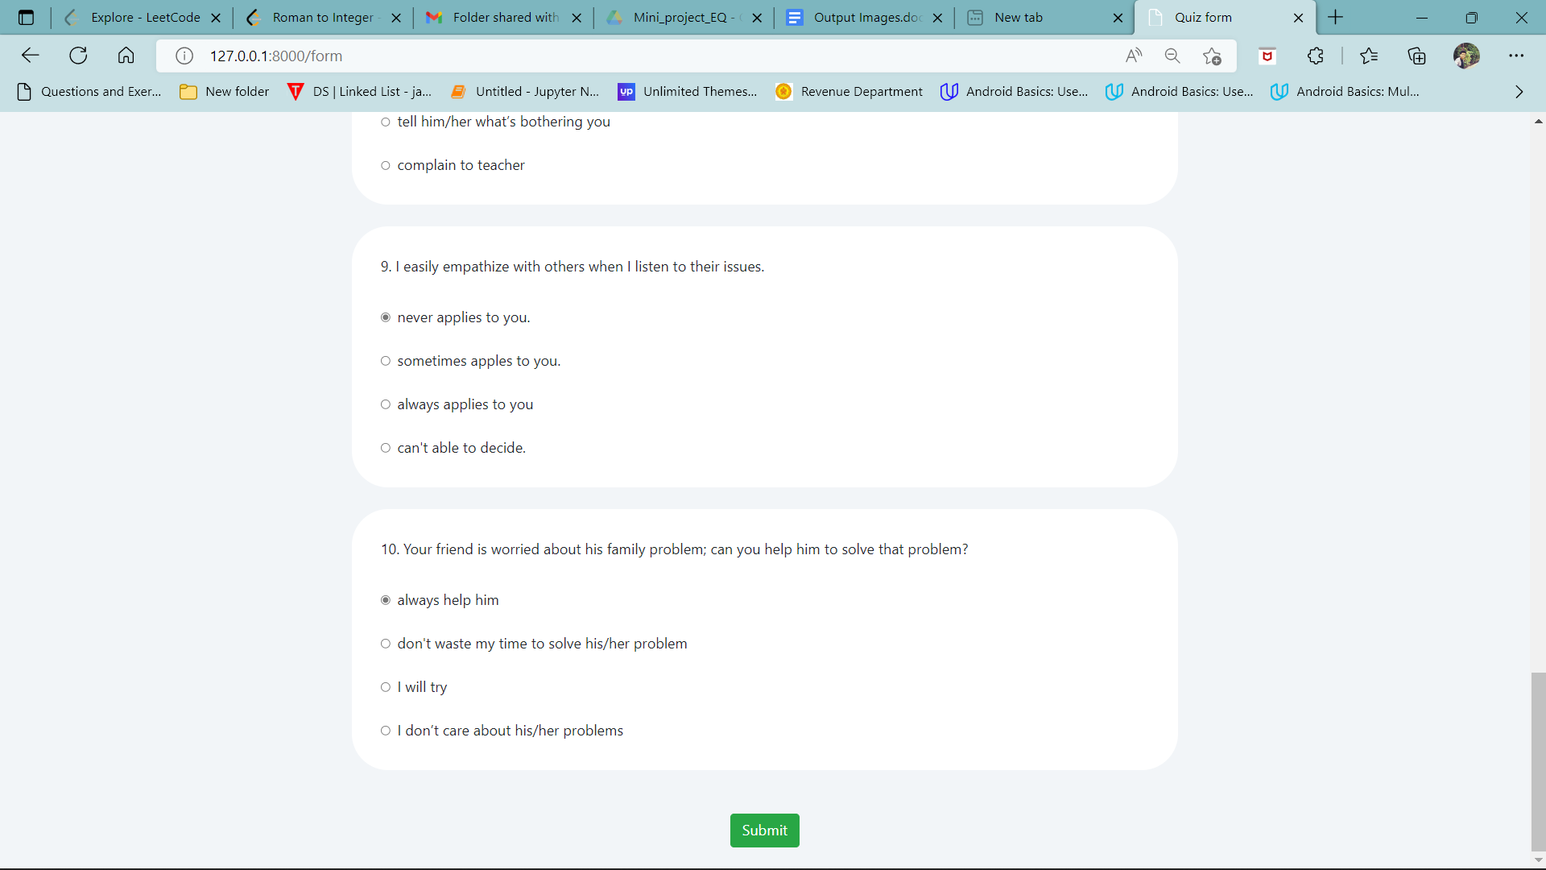

Fig 13. Collected Data aggregated internally

**RECORD UPDATION SECTION**

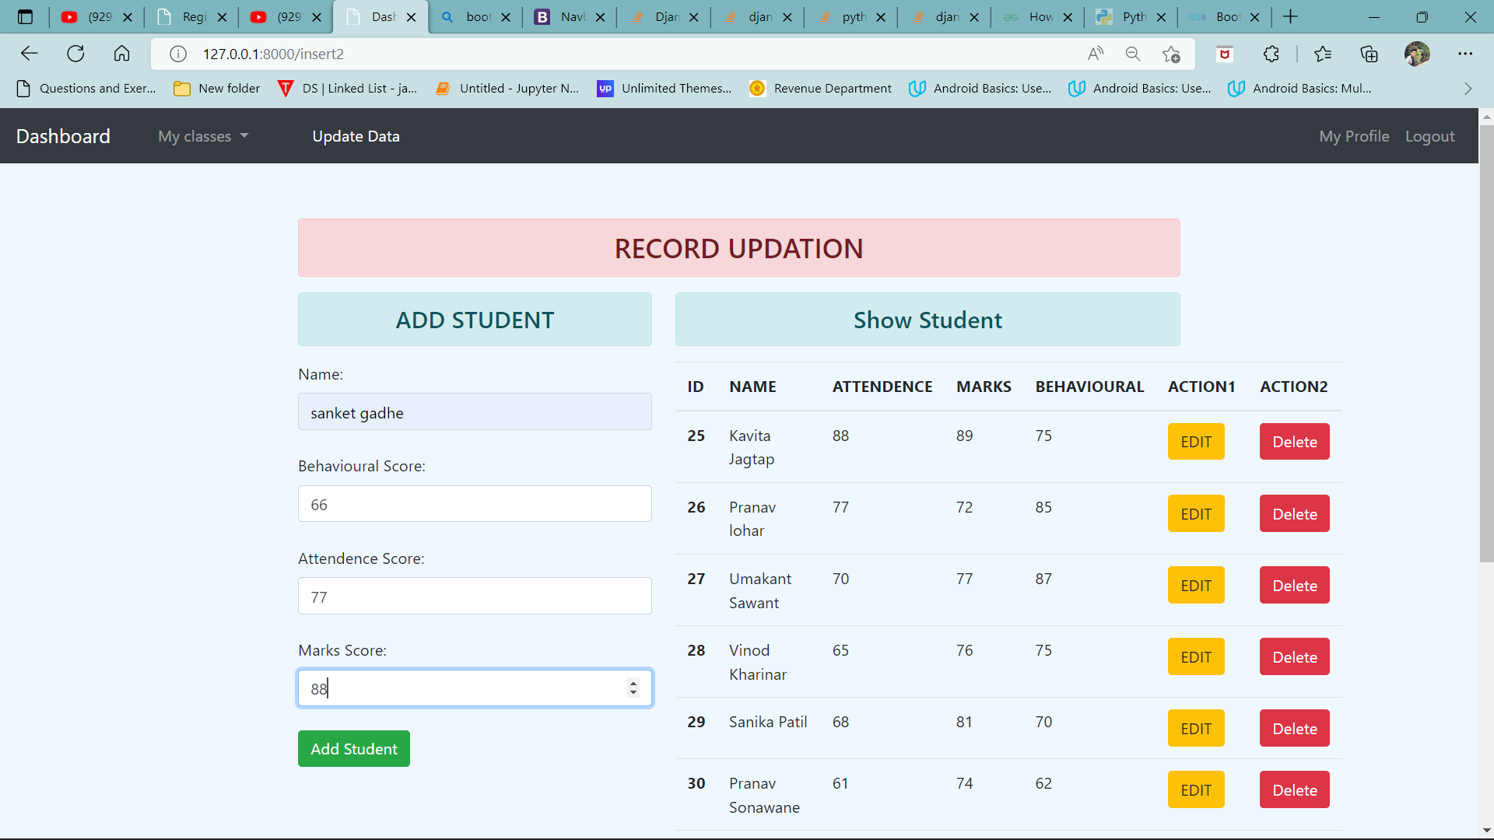

Fig 14. Adding new Student Data and Deletion

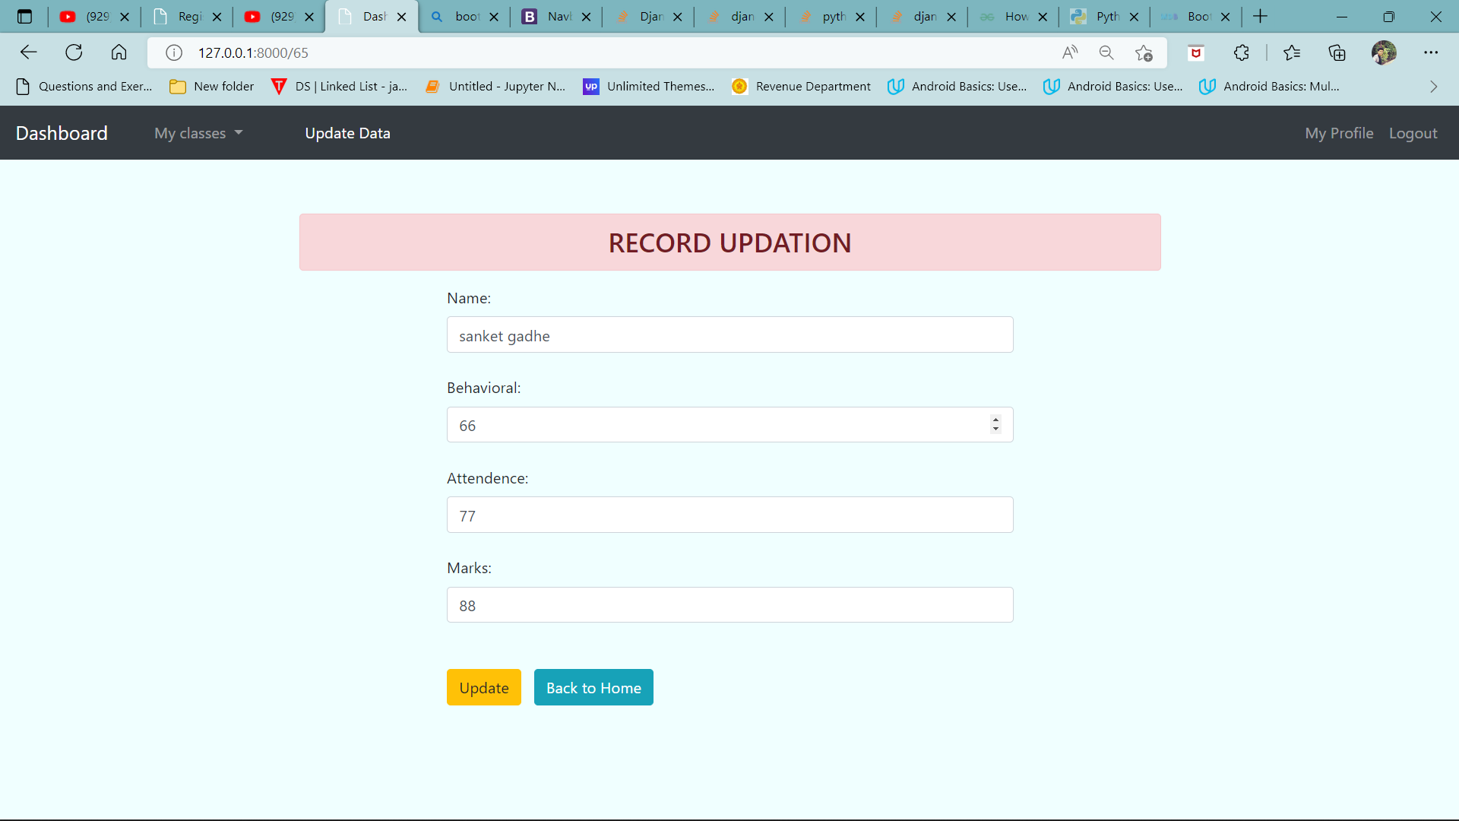

Fig 15. Updating Existing Data